Dear All,

due to the actual situation and unpredictable future of events because of travel restrictions throughout the year, we inform you that we have to postpone the Zoom8 Europeans to 30.4.-3.4.2021.

We hope, that you all stay healthy, and will send you more information regarding the 2021 event later this year.

Best regards

Christian Bayer

Leitung Breitensport & Events

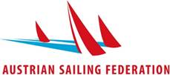

AUSTRIAN SAILING FEDERATION

ÖSTERREICHISCHER SEGEL-VERBAND

Mitglied der BSO, ÖOC, ÖPC, WORLD SAILING, EUROSAF, EBA

ZVR: 375279448

Seegelände 10 | A-7100 Neusiedl am See

phone: **+43 660 87100209** no fax

[christian.bayer@segelverband.at](mailto:christian.bayer@segelverband.at)

[www.segelverband.at](http://www.segelverband.at/)